Geographic distribution of organophosphate-degrading bacteria in soil
Audrey Chibnall
Introduction
Pesticides are commonly found in soil everywhere. Since pesticides are everywhere it is important that scientists learn how to break down the pesticides, so they do not harm the environment. One way to break down pesticides is by using bacteria found in the soil. This study focused on breaking down the pesticide Paraoxon ethyl (Px) and Methyl Parathion (MP). Px is a synthetic aryl dialkyl phosphate and can act as an acetylcholinesterase inhibitor. It is found in the insecticide parathion, and it was found to be dangerous to humans. The other pesticide, MP, can cast as an acetylcholinesterase inhibitor, and has also been found to be dangerous to humans. The use of both of these pesticides has been reduced but there are still traces of them being used and are at risk of harming humans (Speshock, 2022). Both of these pesticides are fairly easy for humans to ingest or absorb so it is important to learn how to break them down so there is no residue of them near humans. To learn what will break down these pesticides, bacteria found in soil was used. The bacteria was cultivated in a Luria-Bertani (LB) broth. LB broth is used to cultivate a wide variety of bacteria. This broth contains vitamins, amino acids, micronutrients, sodium ions, and a yeast extract (Speshock, 2022). All of these characteristics makes this broth an ideal environment to cultivate some bacteria. In order for the bacteria to break down the pesticide, they have to be missing a nutritional factor, so they have no choice but to break down the pesticide. To do this carbon selection media (CSM) and sulfur selection media (SSM) were used. CSM takes away carbon, so the bacteria has to break down the pesticide to get any carbon to survive. SSM takes away sulfur, so the bacteria has to break down the pesticide to get any sulfur to survive. If the bacteria is able to survive in those mediums with the pesticide it show that the bacteria is able to break down the pesticide (Speshock, 2022). The purpose of this study was to find out if bacteria found in the soil is able to metabolize the pesticide.
Methodology
In this study two organophosphate pesticides were used, Paraoxon ethyl (Px) and Methyl Parathion (MP). For week zero Luria-Bertani (LB) broth was inoculated with about one gram of soil that was collected the previous week. This inoculated broth was then left to incubate at 30°C and shaken at 200 revolutions per minute for one week. For week one the pesticides were used. They were prepared in an 1000X stock at 100 milligrams per milliliter. From the 1000X stock 5 microliters were added to 5 milliliters of carbon selection media (CSM) or sulfur selection media (SSM), this made a created a concentration of 100 micrograms per milliliter. Next, one milliliter from the LB culture was added to the 4 milliliters of CSM and SSM with Px. This was then incubated at 30°C and shaken at 200 revolutions per minute for a week. The MP shipment was delayed so the CSM and SSM with the MP was incubated at 37°C and shaken at 200 revolutions per minute for only one day. For weeks two through five the same procedure will be repeated. That procedure is, first receiving four tubes, CSM_Px, SSM_Px, CSM_MP,SSM_MP. These tubes each have 5 milliliters of the media with 1X of the pesticide. Next, 200 microliters from the previous week will be added to the corresponding tube for the current week. For example, during week two, 200 microliters will be taken from the tube CSM_MP from week one and added to the tube CSM_MP for week two. Each week the tubes will be incubated at 30°C and shaken at 200 revolutions per minute for one week. After five weeks, any cultures that were observed as bright yellow were inoculated in the same LB broth that was used at the beginning. This was done by taking one milliliter from the cultures and adding it to four milliliters of the LB. Once inoculated, they were incubated at 37°C overnight. Cultures that had any growth were plated onto a glycerol minimal media with pesticide. The glycerol minimal media was made with glycerol and agar and poured in into petri dish. It was allowed to solidify overnight, and the next day 100 microliters of pesticides were added to the top. Finally, any LB cultures with growth were added to the top of the dishes.
Results
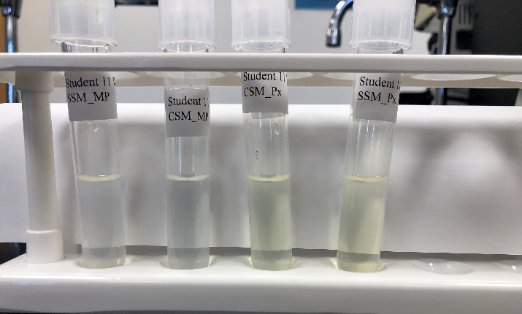
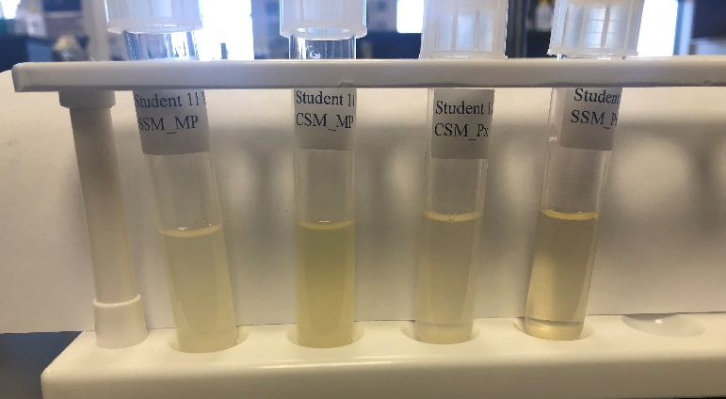
For the soil collection, the soil was collected in Stephenville Texas at the coordinates 32.219749, -98.220724. In Figure 1 is shown how the cultures looked after being inoculated during week one and then left to incubate for one week. The picture shows that all of the cultures had a yellow coloration to them and were very cloudy looking. Figure 2 shows what the cultures looked like after week two. After being inoculated during week two and left to incubate, the cultures had lost a lot of their yellow coloration. They also became less cloudy than after week one. In Figure 3 is shown how the cultures looked after being reinoculated during week two and left to incubate for a week. It is seen that CSM_Px and SSM_Px have regained some yellow coloration. All of the cultures have about the same level of cloudiness that they had the week before. Figure 4 shows the cultures after being inoculated during week three and incubated for a week. It shows that CSM_MP and SSM_MP have both remained clear with no yellow coloration. On the other hand, CSM_Px and SSM_Px have both maintained their yellow coloration. Finally, Figure 5 shows the cultures after being inoculated a final time and left to incubate for a week. It shows that CSM_MP and SSM_MP both lost their color while CSM_Px and SSM_Px both maintained their yellow coloration. Figure 5 also shows LB cultures that were inoculated with some media from CSM_Px and SSM_Px that was incubated overnight. After the five weeks the cultures CSM_Px and SSM_Px were inoculated into another LB broth and then put on to a petri dish. On the petri dish they showed to have some growth.
Figure 1
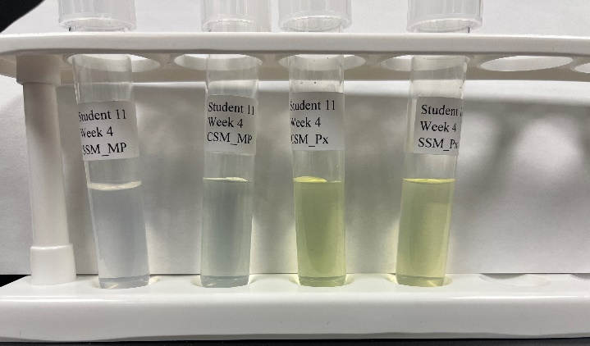
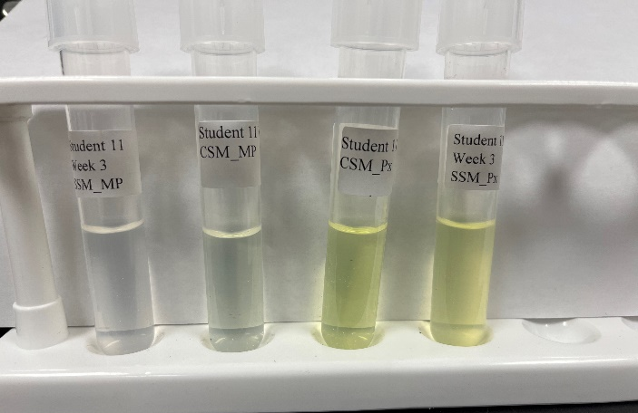
Figure 2

Figure 4
Figure 3

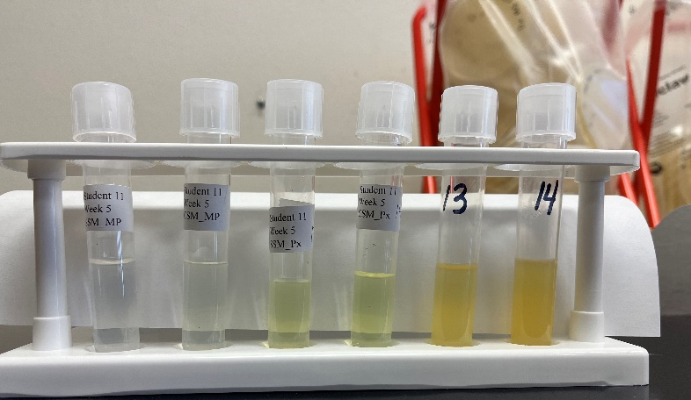

Figure 5

Discussion
The point of this study was to find bacteria that can break down pesticides, specifically CSM and SSM. If the bacteria that was in the soil collected can break down the pesticide it will be known by the culture having a yellow coloration. As seen from the results out of the four cultures only two were successful in breaking down the pesticide. Only the bacteria found in the cultures CSM_Px and SSM_Px was able to break down the pesticide. The bacteria in the cultures for CSM_MP and SSM_MP were shown to still be alive during week one, but they were unable to break it down, so they did not survive. This is seen by the loss of the yellow coloration by week two. However, the CSM_MP and SSM_MP were only inoculated for one day before the picture was taken. There was not a lot of time for them to cultivate and to see if they were actually able to break down the pesticide or not. Since they had only been incubating for one day the results for CSM_MP and SSM_MP for week one were not very accurate because they were not given enough time. After the cultures from CSM_Px and SSM_Px were inoculated into a LB broth and put on to a petri dish, they were shown to have some growth. This growth shows that this bacterium is able to break down the pesticide.
For this study there were some issues. One issue was the shipment for the pesticide MP was delayed so for the first week it was only able to incubate for one day instead of one week. This skewed the results from week one a little because the bacteria was not given enough time. Another issue was that none of the bacteria with the pesticide MP were able to break down the pesticide. This was strange because in other studies there was some bacteria that could break it down. There is not definite reason that this happened for this specific study but there are a lot of different factors. Maybe there is a very small number of bacteria that can break down MP and just none of the soil samples had those bacteria. Maybe the bacteria did not have the right conditions to grow in. Maybe the MP pesticide used for this study was slightly different than the MP used in other studies. There is no way to know the exact reason for this issue but there are some ideas. Another issue was growing the cultures on agar plates. For some reason the cultures would not grow, and it took many tries for them to successfully grow. Once again, the reason for this issue is not known, but the cultures were eventually able to grow.
This study found that it is possible to use bacteria found in the soil to break down pesticides. The most successful bacteria was able to break down CSM_Px and SSM_Px. The presence of the bacteria was seen by the yellow coloration in the cultures. This showed that the bacteria was able to survive by breaking down the pesticide to collect nutrients. While there were some issues, overall, this study showed that it is possible for bacteria to break down pesticides.

References
Speshock J. 2022. Env Sampling Research BIOL-4090-020. Protocol Details.

