The Search for Pesticide Bioremediating Bacteria in Locally Sourced Soil

The Ability of Soil Bacteria to Degrade Paraoxon and Methyl Parathion

Introduction
Pesticides are substances that are used to control the presence of insects, weeds, and other disease carrying pests that are harmful to plants or animals. The United States is so reliant on the use of pesticides that about one billion pounds of conventional pesticides are used each year.
Today, pesticides are at the forefront of farming and agriculture; they help save labor, provide a higher yield, and shield crop from disease. Pesticides have been deemed the answer to many agricultural problems, but at what cost? Pesticides are now known to be highly toxic, and after countless studies have linked pesticide usage to the development of cancer and other diseases, efforts to reduce pesticide contamination are now being researched.
One such effort includes the use of bioremediation to rid soil of pesticides. Bioremediation is the use of microorganisms to break down or consume environmental pollutants. In this research, a sample of local soil was used to study its’ inhabiting bacteria’s ability to degrade two different pesticides: Paraoxon and Methyl Parathion. Bacteria from the soil sample was added to four different types of media: carbon selecting media with Paraoxon (CSM_Px), carbon selecting media with Methyl Parathion (CSM_MP), sulfur selecting media with Paraoxon (SSM_Px), and sulfur selecting media with Methyl Parathion (SSM_MP).
Bacteria, like all organisms, utilize six essential elements to survive: Hydrogen, Oxygen, Nitrogen, Phosphorus, Carbon, and Sulfur. These substances are obtained from the surrounding environment, and if one of these substances is not present or usable, the bacteria will not survive. The carbon selecting media contained all essential elements except carbon. If the bacteria were to survive in this media, it would need to break down the carbon from the pesticide and use it instead. The same is true for the sulfur selecting media; all essential elements except sulfur were present. If there was bacterial growth in the media, which was indicated by a bright yellow color change due to the p-nitrophenol indicator, this was indicative of the bacteria’s ability to degrade the pesticide.

Materials and Methods

Week Zero
This week, soil collection and inoculation was performed. After the location was chosen, which happened to be at the coordinates 32.21300 N, 98.22182 W, about three inches of the ground was dug into and a small amount of soil was collected into a tube. The exact GPS coordinates were recorded. Next, 1 gram of the soil was weighed out and added to an LB broth tube. The cap was placed loosely on the tube, and it was incubated at 30°C shaking at 200 RPM for one week. This allowed bacteria from the soil to grow aerobically.

Week One
Each pesticide, Paraoxon (Px) and Methyl Parathion (MP), were prepared in a 1000X stock at 100 mg/mL. 5 µL of each stock was then added to 5 mL of CSM and SSM which created a 1X concentration at 100 µg/mL. 4 mL of each of these were added to tubes and labeled: week 1 CSM_Px, week 1 CSM_PM, week 1 SSM_Px, and week 1 SSM_MP.
1 mL of the soil broth from week zero was added, using a pipette, to tubes CSM_Px, and SSM_Px. Care was taken not to transfer any soil debris into the week one tubes. After, the tubes were capped and incubated for one week at 30°C and shaking at 200 RPM. A shipment of the MP was delayed so the tubes with MP were prepared later and incubated at 37°C shaking at 200 RPM for 1 day.

Weeks Two Through Five
Pictures of the previous week’s tubes were taken each week to evaluate changes in the tubes and four new ones were prepared each week with the indicator, p-nitrophenol, and 5 mL of the same media as before: CSM_Px, SSM_Px, CSM_MP, SSM_MP. The tubes were labeled for the new week, and with a pipette, 200 µL of previous week’s culture were added to the corresponding new week’s tube. After the transfers were complete, the caps were replaced, and the tubes were incubated for one week.
Any samples with strong indication of bacterial growth were then revitalized in LB broth in a 1 mL to 4 mL dilution, and if growth persisted, the sample was plated for bacterial colony observation.

Results

Week One
After one week of incubation, there was no visible changes in the tubes.

Week Two
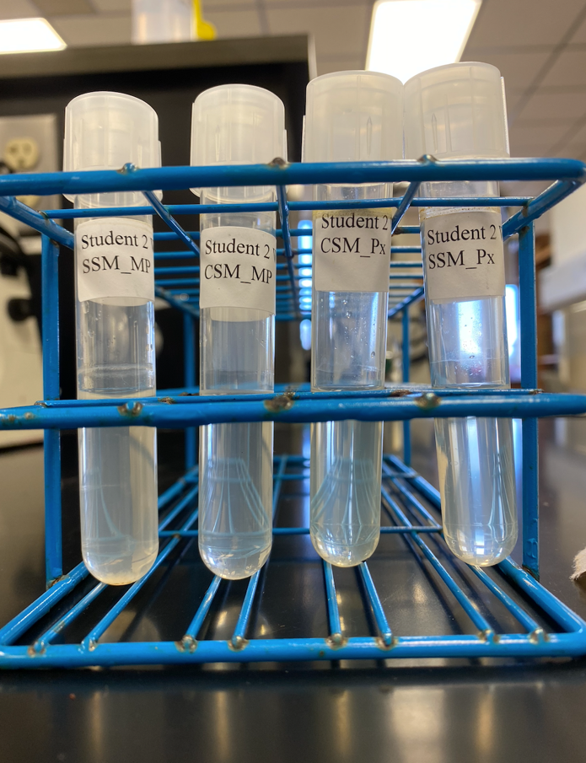
No growth seems to have happened as the samples are clear and clean.

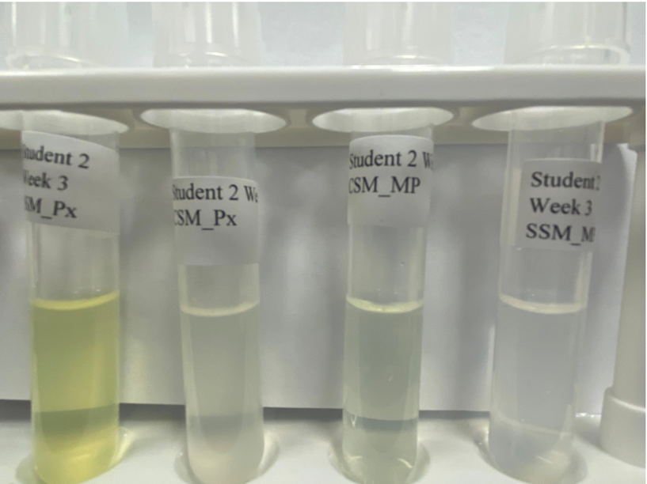
Week Three
Noticeable color change in SSM_Px and very slight color change in CSM_MP. No visible changes in the other tubes.

Week Four
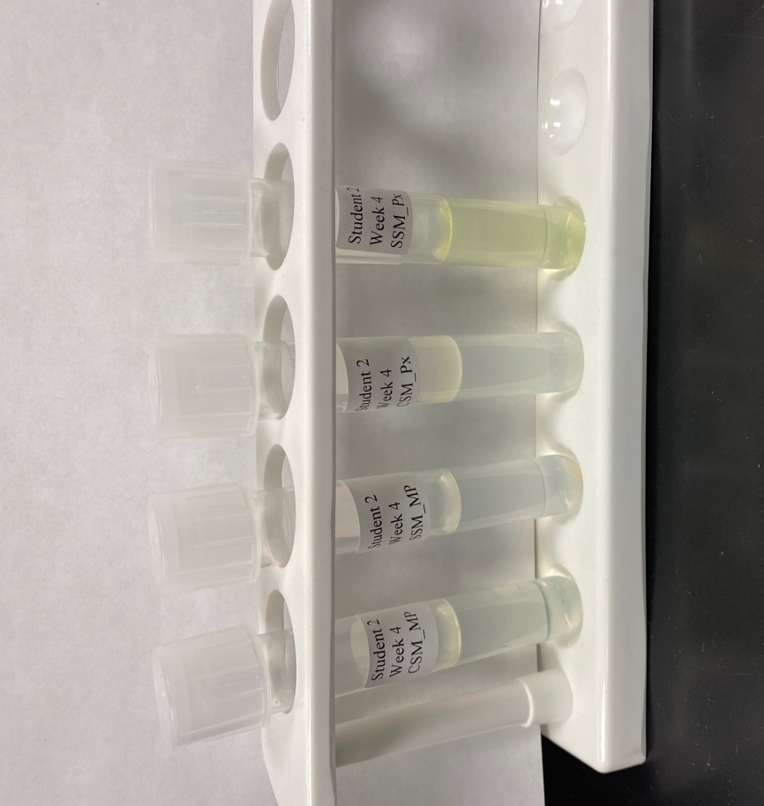
Still an apparent color change of yellow in the SSM_PX tube and a very slight color difference in the CSM_MP tube. Some type of orange/white substance has settled in the bottom of the SSM_MP tube and will float around if you swirl the tube.

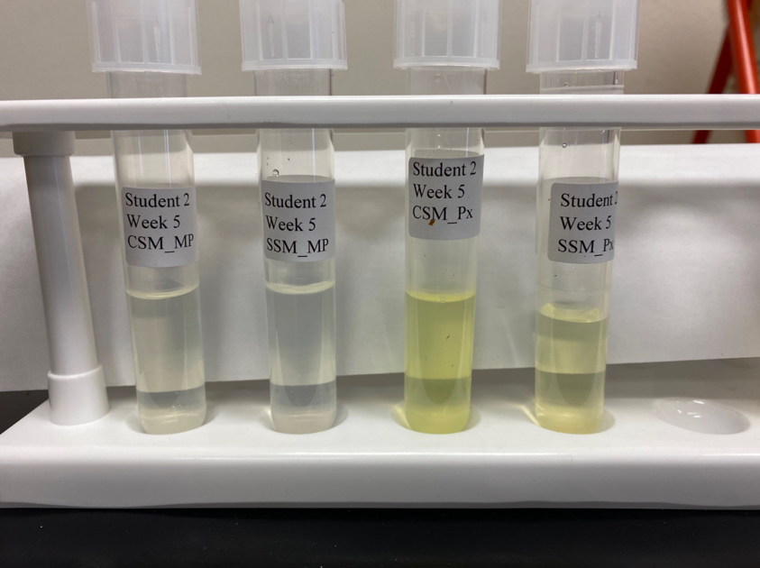
Week Five
The color of CSM_Px is now bright yellow. The color of SSM_Px is pretty much the same but possibly less vibrant.

Revitalized LB Culture
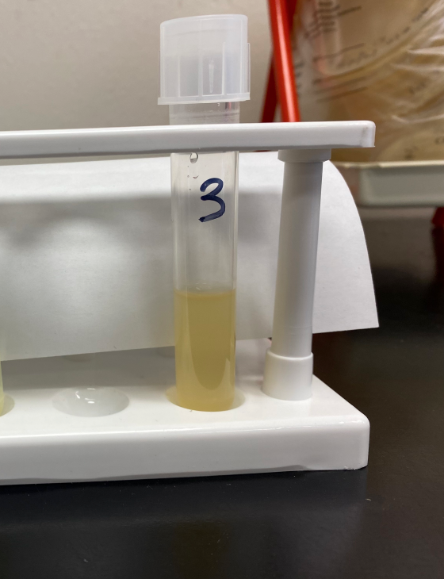
The SSM_Px was indicative of bacterial growth and chosen to be revitalized in new LB broth. This too, was a dark color indicative of growth so it was later plated.

Plating
No growth occurred after plating.

Conclusion
After a five-week growth period, the SSM_Px sample was indicative of growth, which began to show by the third week, and successfully revitalized in LB broth. However, after plating, there was not any more bacterial growth.

References
Pesticides active. Pesticides | U. S. Geological Survey. (n.d.) Retrieved From https://www.usgs.gov/centers/ohio-kentucky-indiana-water-science-center/science/pesticides#overview

