Analysis of Potential Pesticide Tolerance in Bacteria for Environmental Sampling Research

Aeron Pennington

Bioremediation is a topic of increasing interest in the global community. Pesticides are designed to kill weeds, insects, rodents, and fungi; with the unfortunate side effect of causing damage to the environment. The goal for this project is to search for any soil bacteria capable of breaking down organophosphates. A soil sample collected at the Tarleton Agricultural Center was grown in LB broth, then the sample was grown in two different medias with two different pesticides: four tubes in total. The samples were passaged over the course of five weeks. Each week, the previous sample was put into a new tube containing selective media and one of two pesticides: Paraoxon (Px) or Methyl Paraoxon (MP). After five weeks, if a sample was indicated to have continuously grown bacteria, then it was plated to examine growth. Most students had samples grow in CSM_Px, indicating that some pesticide tolerant bacteria had been grown over the semester. Further research and work would need to be done to identify what species of bacteria grew in the media and how they could metabolize the pesticide Paraoxon.

Introduction:
Pesticides, while useful in the agricultural industry, can cause serious, lasting damage to the environment. Some pesticides can seep through soil, depleting naturally growing bacteria and contaminating the groundwater [1 & 4]. These chemicals can also be washed into rivers and streams, poisoning fish, amphibians and even the water itself [1]. Roundup, one of the world’s most common pesticides is implicated as both a carcinogen and a potential causative agent for Parkinson’s Disease [2].

The purpose of the study is to identify soil bacteria that can potentially metabolize and eliminate harmful pesticides from soil, specifically organophosphates. If an organism can break down, or metabolize, a compound

for energy, it can potentially be removed from the environment. Usage of pesticides
has been tied to dramatically decreasing numbers of beneficial insect species [1 & 4]. Removal of harmful and damaging pesticides could help mitigate some of the environment damage caused to the soil by humans.

Pesticides can be designed to kill different organisms; some focus on rodents and insects, while others focus on fungi or weeds. The active ingredient in Roundup, Glyphosate has a half-life somewhere between three days and 19 week (133 days) [3]. The two pesticides used for this project, Paraoxon (Px) and Methyl Parathion (MP) are both acetylcholinesterase inhibitors. Acetylcholine is an important neurotransmitter in the brain and responsible for muscle movement throughout the entire body. Inhibition of this chemical transmitter can result in paralysis, and in high enough doses, death.

Materials and Methods:

Pesticides and Media:
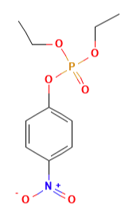
Paraoxon is an extremely potent toxin [5]. Figure one gives an image of the chemical structure. This is the active ingredient in the pesticide Parathion, the use of which has become highly restricted. Parathion is broken into Diethyl Thiophosphate and 4-Nitrophenol when degraded by hydrolysis [5 & 6].

4-Nitrophenol is often used as a pH indicator in laboratory settings, turning yellow above a pH of 7.5 [7]. This chemical is also frequently used to identify alkaline phosphatase enzymes [7]. It should be noted that 4-Nitrophenol is a toxic compound, functioning as an uncoupler [8]. Uncouplers disrupt Oxidative Phosphorylation, the source for ATP production in a cell [8].
Figure 1: Structure of Paraoxon

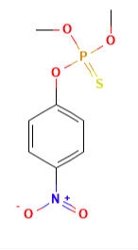
Methyl Parathion (MP) is an acetylcholinesterase inhibitor, mostly used on cotton and non-food crops. The EPA has limited the usage of this pesticide, as it has proven to be dangerous to inhale, ingest and can be absorbed through the skin [10-11]. Overexposure from handling the pesticide can result in severe toxicity [10]. Methyl parathion can be metabolized to Methyl Paraoxon, which is similar to the previous pesticide [10].
Figure 2: Structure of Methyl Parathion

Media:
Luria-Bertani (LB) broth is used initially, to grow a wide variety of bacteria in the soil sample. Luria broth is used primarily to grown aerobic bacteria in the Enterobacteriaceae family. Escherichia coli is also commonly grown in LB media. 1.0 gram of the initial soil sample was grown in this media and further samples were grown in Carbon Selective Media (CSM) and Sulfur Selective Media (SSM).

Carbon selective media (CSM) is a media that contains everything but carbon. All forms of known life use Carbon as an energy source, and if an organism is to survive in this media, then it would need a carbon source. For this experiment, the two pesticides are serving as the carbon source. If the bacteria in this media can survive, it is l because they can, in some way, metabolize Px or MP. There are two tubes: one containing CSM_Px and another with CSM_MP.

Sulfur selective media (SSM) is a media that contains many necessary nutrients for growth and survival but lacks sulfur. Sulfur is another important macromolecule, necessary for life. Two tubes, each containing the media and one of the two pesticides are used to select for bacteria that can metabolize a pesticide for a source of energy.

Soil Collection:
One gram of soil was collected from the Tarleton Agricultural Center. Two different fields are separated by a driving road; one side has a peanut field, and the other side has a pecan grove. The soil sample was collected from the outside of the pecan grove, alongside an area that is known to be regularly sprayed with Roundup. Another student collected their sample from the middle of the peanut field, represented by the red dot in Figure One. The blue dot in Figure One is the sample collected alongside the pecan grove.

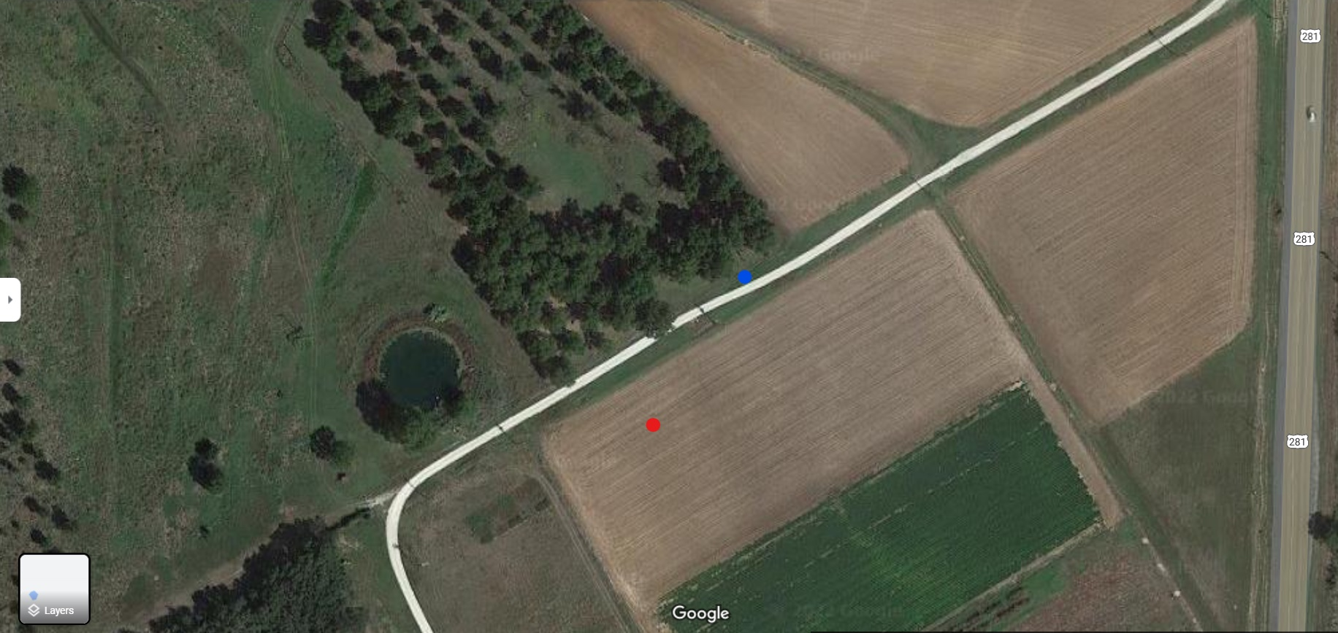
Figure 3: The red dot represents another student who collected from a peanut farm at the Tarleton Agricultural Center. The blue dot represents the soil sample that is the focus of this paper; collected from a roadside along a pecan grove. The border of the grove is known to be regularly sprayed down with Roundup.
Five different soil samples were collected from alongside the road, then blended into a clean bucket to thoroughly mix the soil. One gram from this mixture was collected and then brought into lab for selective growth. The sample was grown in LB media, which is a media that can be used to grow a wide variety of bacteria.

Soil Passaging:
Four tubes containing samples were maintained over the course of five weeks. Each week, 200 μL of sample from the previous week is put into a new set of test tubes. Four tubes in total: CSM_Px, CSM_MP, SSM_Px and SSM_MP. The samples were then grown for a week at 30°C. Photographs were taken each to track the growth of each sample within their tubes.

From the initial LB grown sample, 1 mL was moved into four different test tubes: CSM_Px, CSM_MP, SSM_Px and SSM_MP. Each tube contained 1X concentration of the pesticide with 4 mL of media. Therefore, 4 mL of media and 1 mL of sample becomes a 1:5 dilution. For weeks 2-5, 200 μL of the previous week was passaged into the new media. This created a 1:25 dilution each week.

Revitalization:
Samples that retained a yellow-ish color throughout each week were indicated to have bacteria that can metabolize a pesticide. 1 mL from this sample was moved into 4 mL of LB broth, to allow for the surviving bacteria to replicate for one week.

Plating:
A sample from the LB broth of surviving bacteria was plated to see what grew.

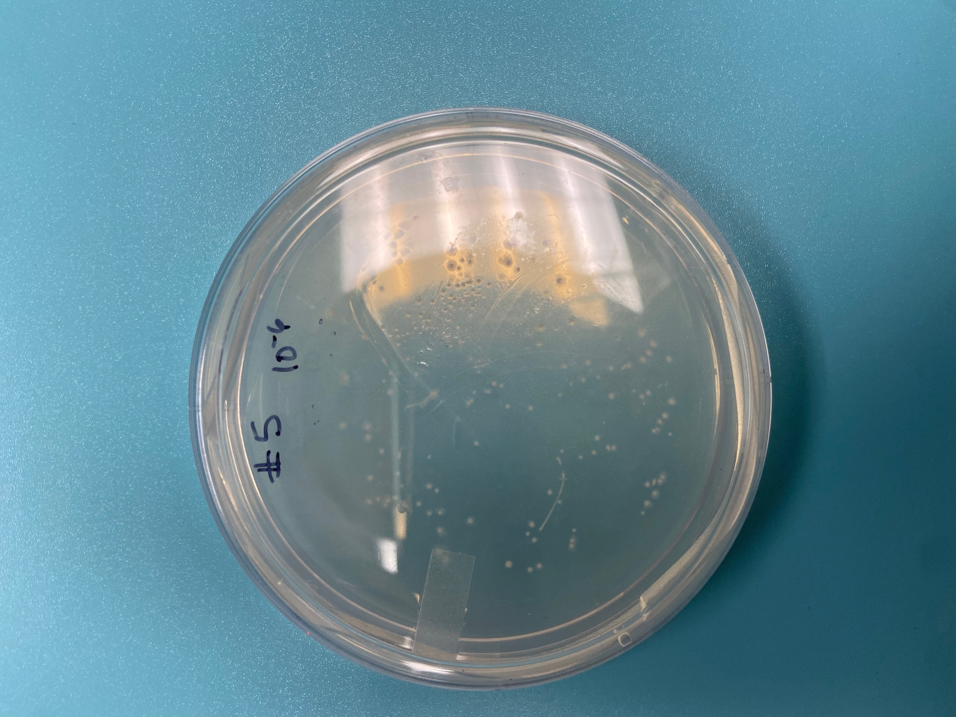
Figure 4: Plate for Student #5, sample from CSM_Px

Student T-Test:
A two sided T test was conducted to examine if two different groups of samples were statistically significant; P < 0.05. The two groups were divided up by major, for the most even breakdown of growth.

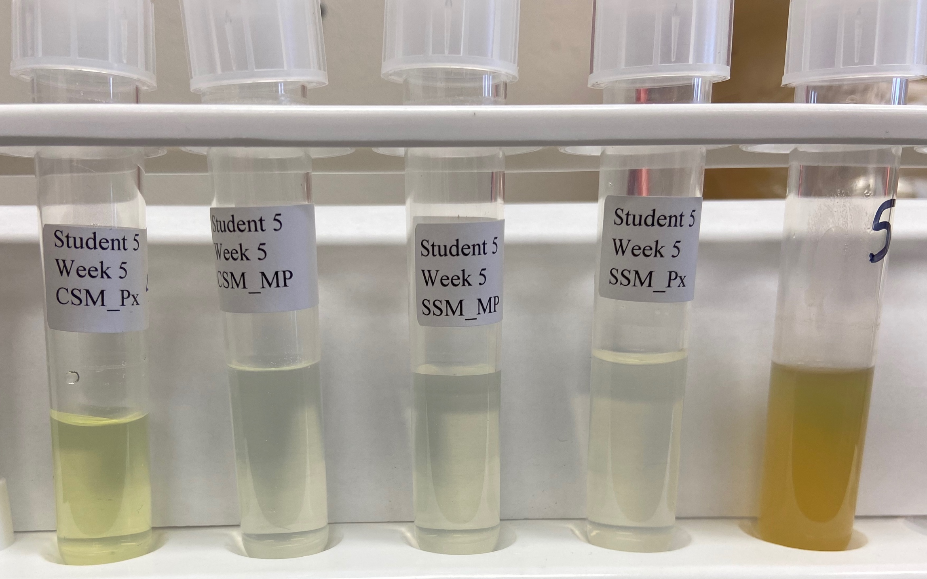
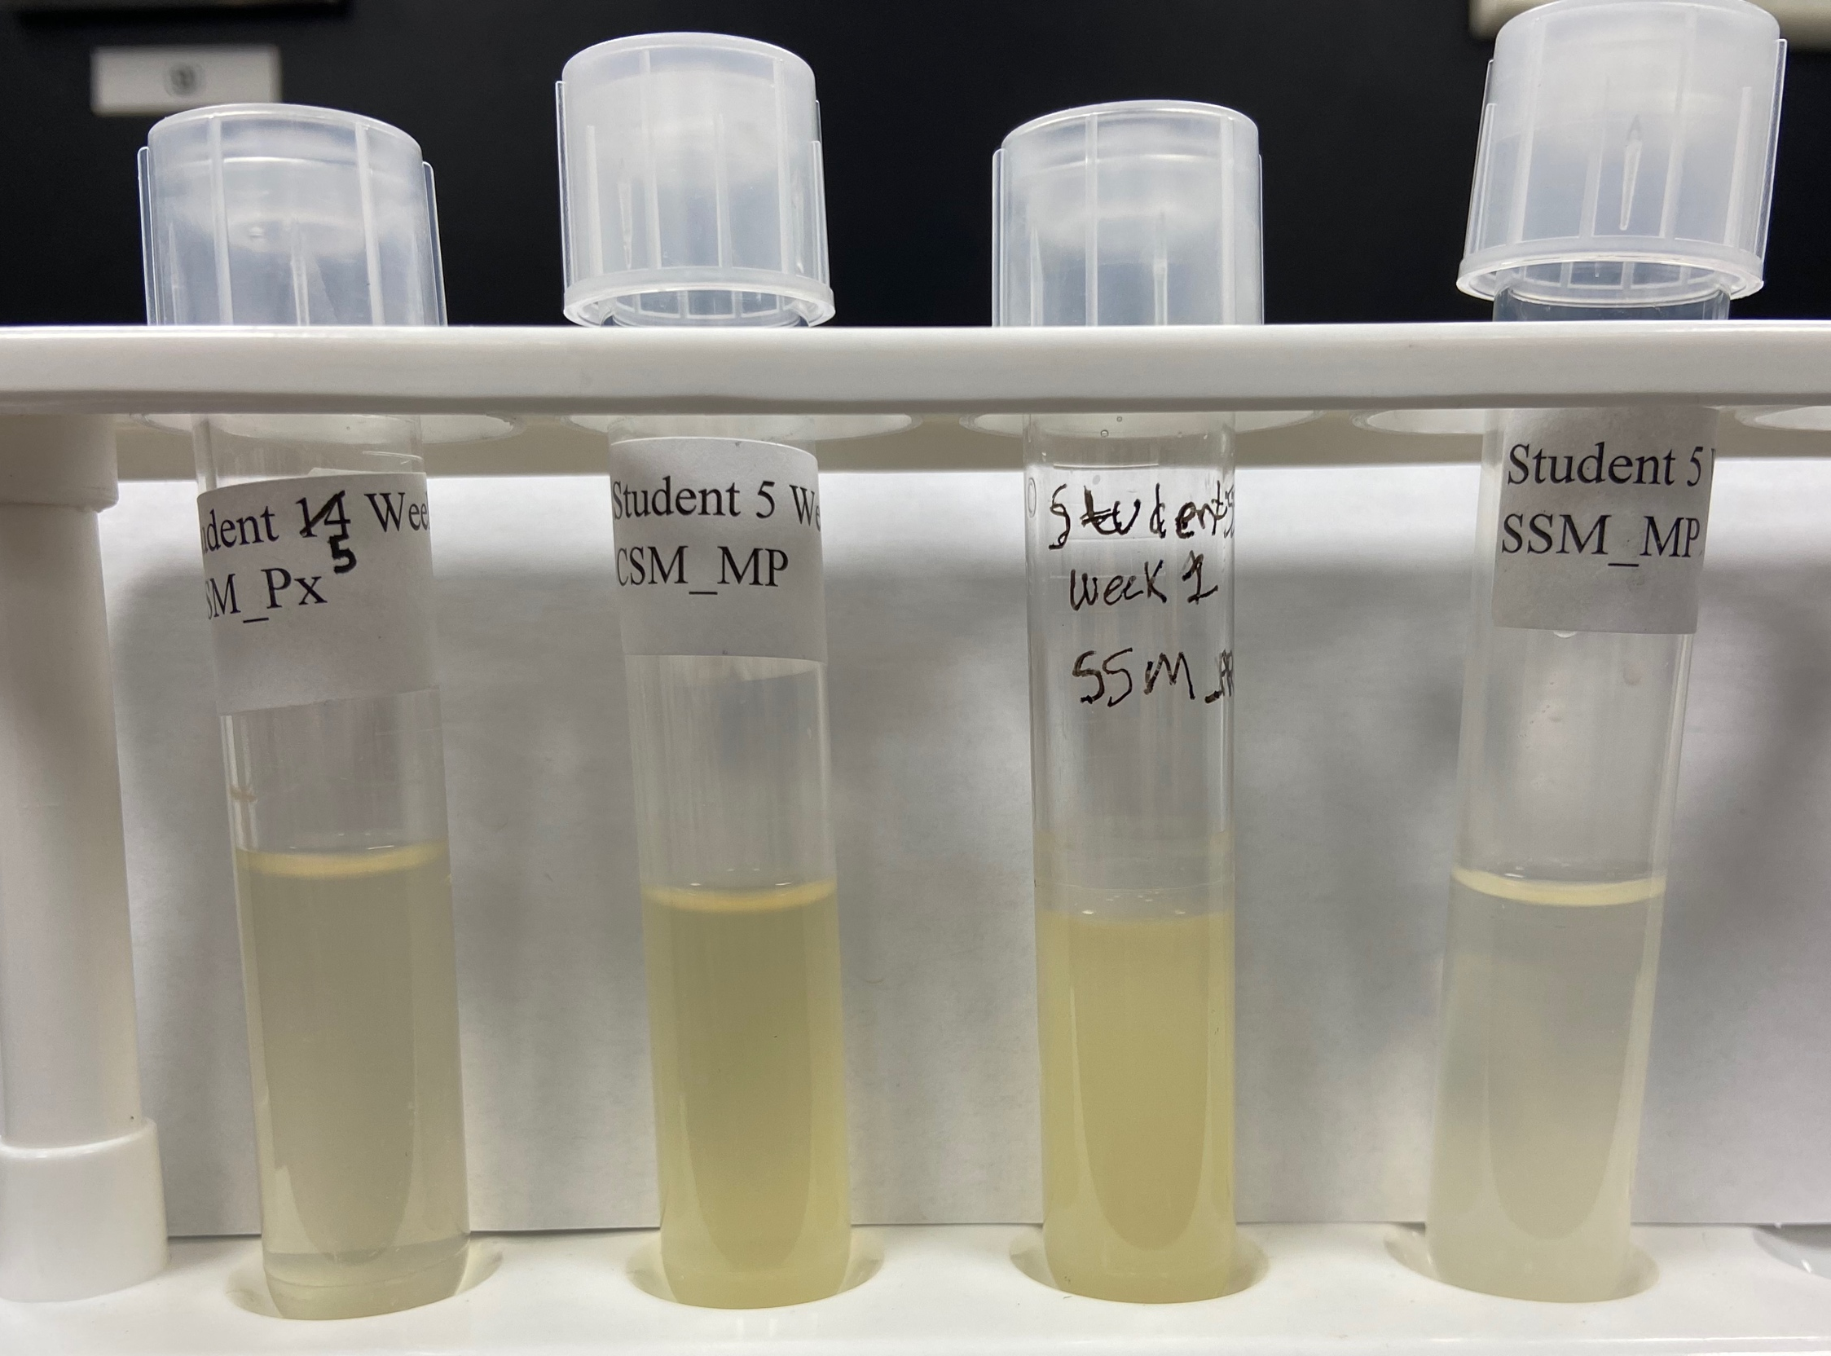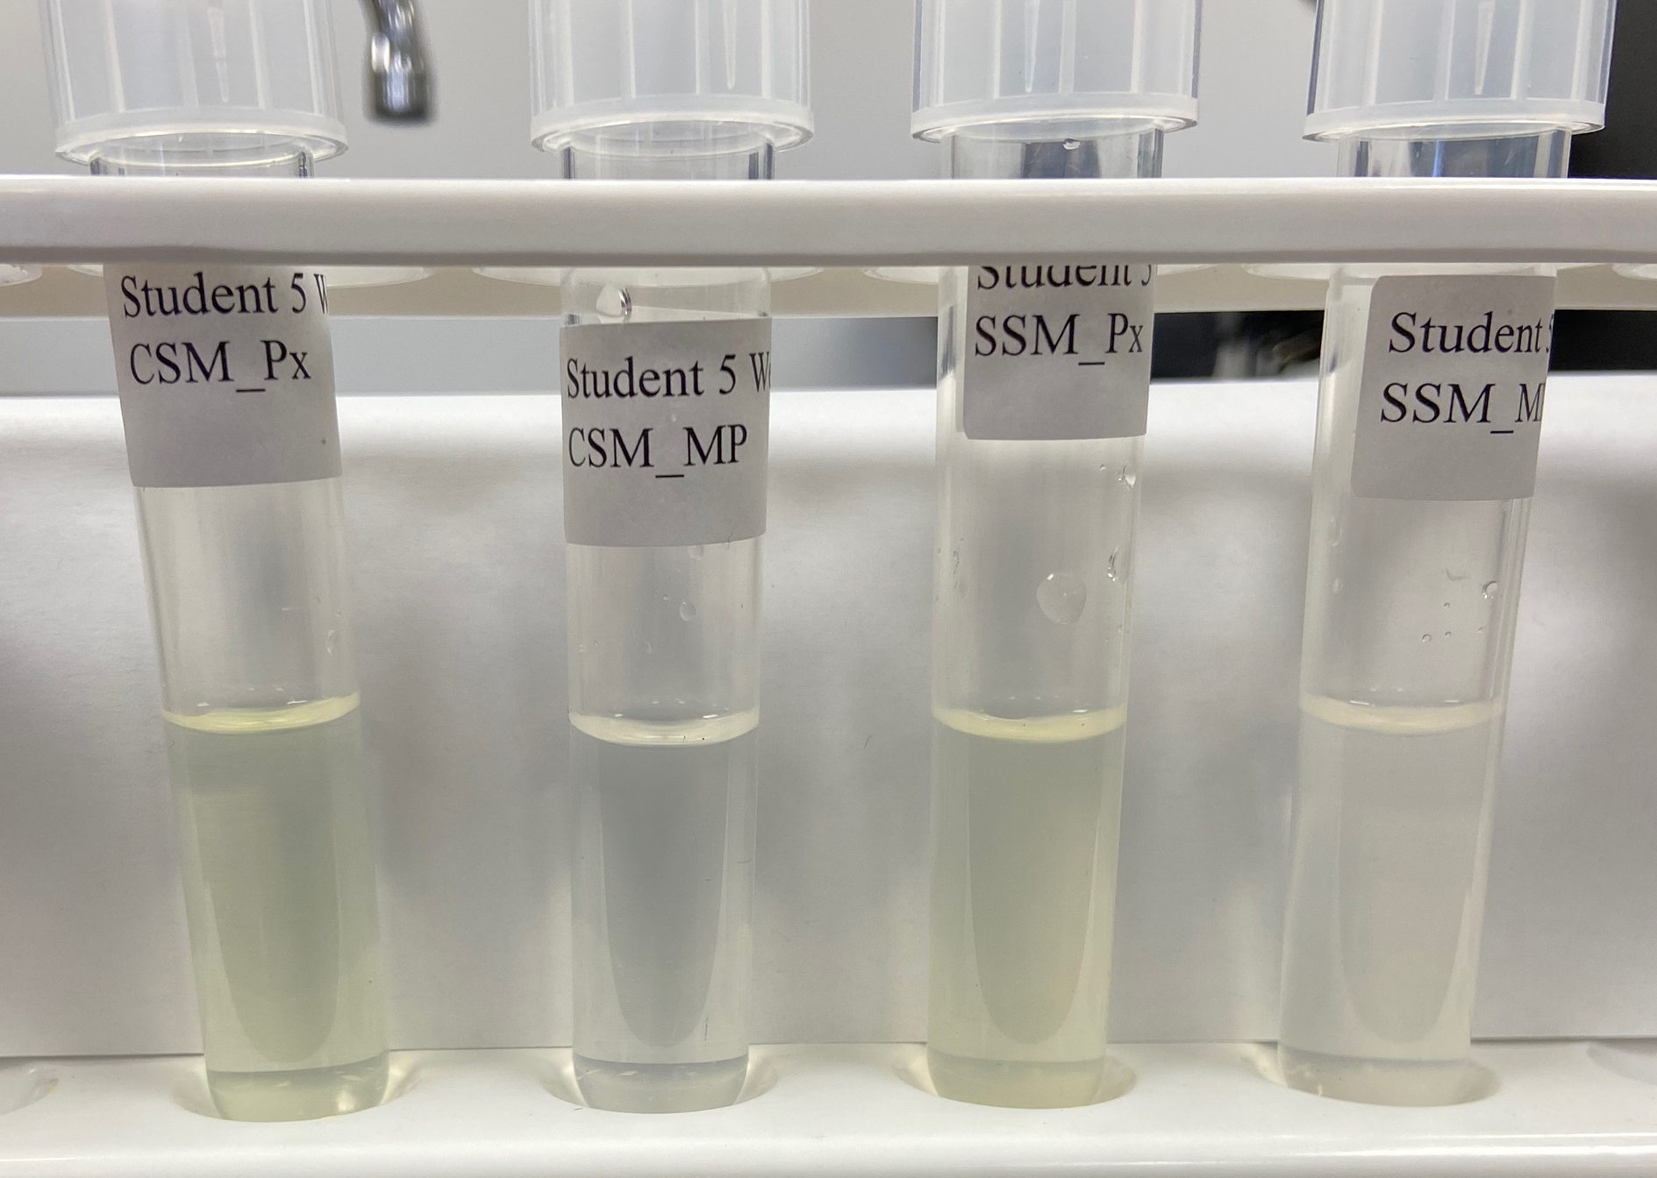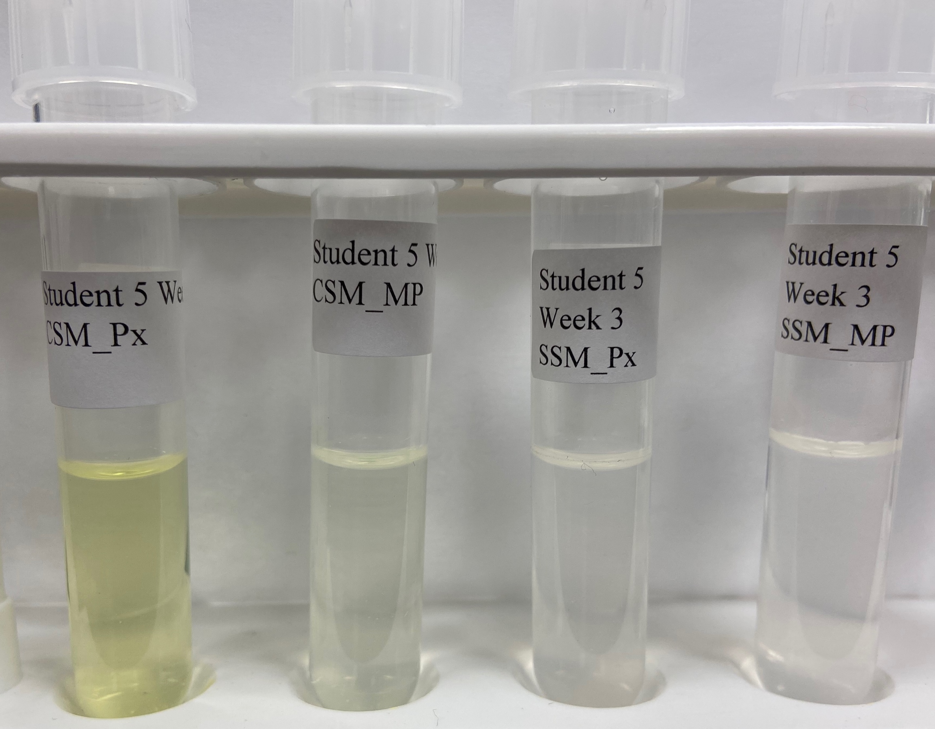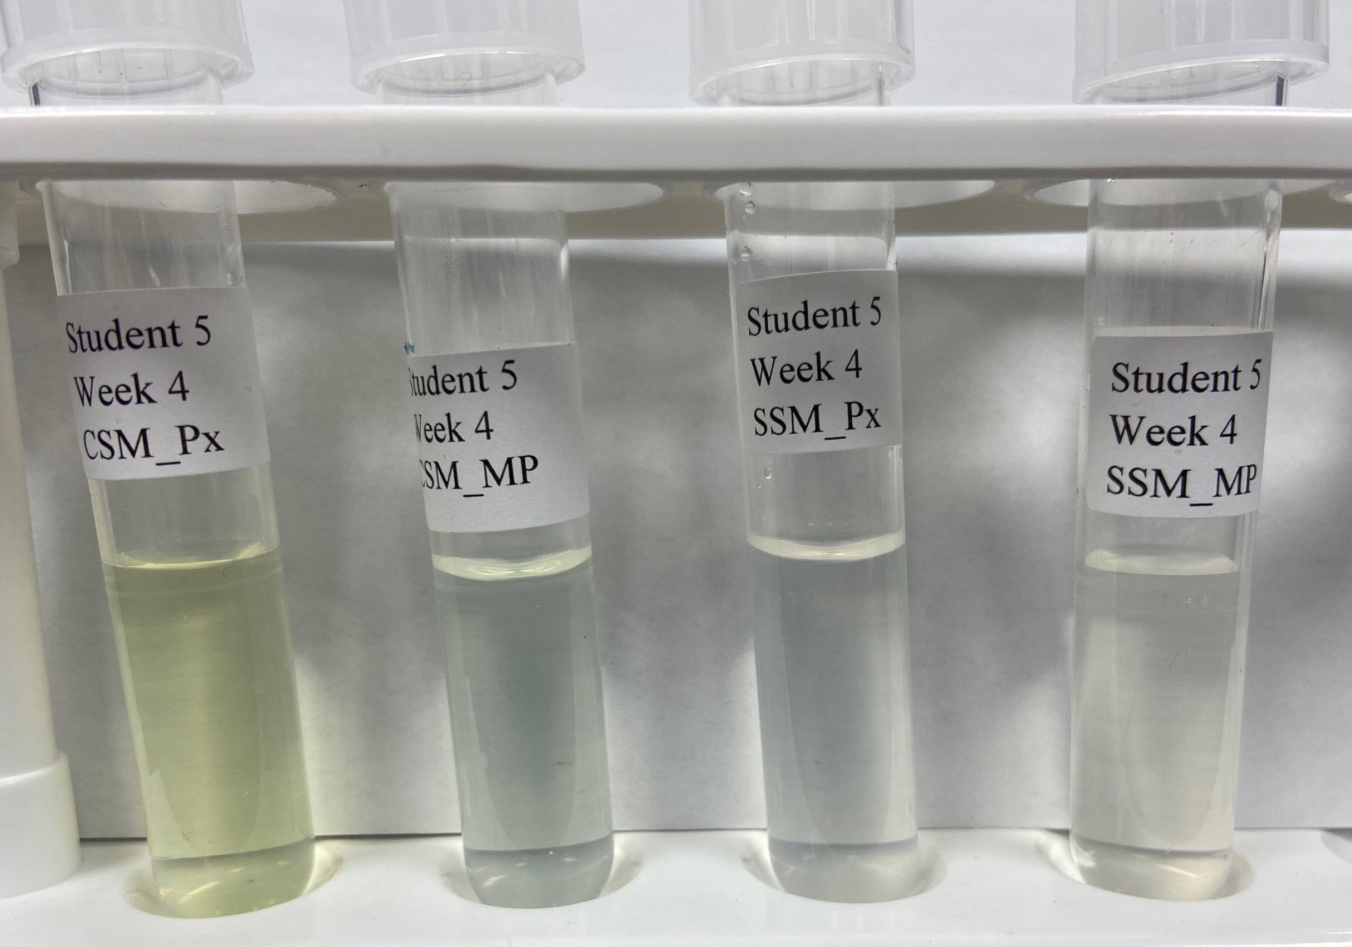

Table One:
From left to right, top to bottom: Week 1, Week 2, Week 3, Week 4, Week 5. Consistently, only CSM_Px had a yellow color to it, an indicator of continued bacterial growth.

Results and Discussion:
Over the course of five weeks, only one tube was able to retain color; an indication that the bacteria within the sample were metabolizing the pesticide. From table one, only CSM_Px was able to maintain its color. The bacteria in this sample are likely to be somehow metabolizing Paraoxon as a carbon source. 1 mL of this sample was revitalized in the LB media and then plated. There was bacterial growth on the plate, as pictured in figure four. Further testing could be conducted to discover which species of bacteria were growing in the media. Bioinformatics can provide genetic information and could potentially help identify genes and pathways responsible for some pesticide metabolism.

The sample for student 5 was chosen with purpose. Student 3 and 5 both went to the same area, Tarleton Agricultural Center, and chose two very different soil conditions. Student 3 collected their sample from the middle of a peanut field while Student 5 collected from an area regularly sprayed with Roundup, alongside a pecan grove. If any bacteria still alive from this sprayed section, then in theory they would be more likely to survive or metabolize pesticides. Glyphosate, the active ingredient in Roundup, contains an organophosphate group. However, it is not an acetylcholinesterase inhibitor. Glyphosate inhibits the Shikimate Pathway, an important pathway in the metabolism of aromatic amino acids [12]. This inhibits the growth of a plant, in theory a weed.

The Student T-Test showed there was no statistical significance between the two groups, with a P value of 0.51, much greater than 0.05. The two groups were separated by their major, to provide a more even breakdown of information.

Concluding remarks:

The goal of the project is the gather information regarding soil bacteria capable of metabolizing organophosphates. From the results of student 5 samples, there are likely bacteria capable of breaking down Paraoxon. This project is being conducted by students and universities all over the country. The intent is to discover bacteria and biological pathways could help mitigate the damage done to the environment through the usage of pesticides. This a wide-scale project and continued work needs to done in order to provide more information.

References:

[1] | Environnemental Impacts. Pesticide Action Network of North America.
[2] | Ascherio A, Schwarzschild MA. The epidemiology of Parkinson's disease: risk factors and prevention. Lancet Neurol. 2016 Nov;15(12):1257-1272.
[3] | Glyphosate Chemical Fact Sheet, 2012. Wisconsin Department of Natural Resources, pdf.
[4] | Cornelisse, T., Donley, N., Klein, K. 2021. Agricultural Pesticides Cause Widespread Harm to Soil Health, Threaten Biodiversity. Center for Biological Diversity.
[5] | Paraoxon Compound Summary, Pubchem.
[6] | Metcalf, R. L., 2014. Insect Control. Ullmann’s Encyclopedia of Industrial Chemistry.
[7] | Ninfa, A., 2010. Fundamental Laboratory Approached for Biochemistry and Biotechnology. Wiley. Pg. 153, 243.
[8] | Terada, H., 1990. Uncouplers of oxidative phosphorylation. Environmental health perspectives vol. 87: 213-8.
[9] | Cholinesterase Inhibitors, National Library of Medicine.
[10] | Methyl Parathion Compound Summary, 2014. Pubchem.
[11] | National Research Council. Drinking Water & Health Volume 1  Washington, DC: National Academy Press, 1977., p. 627
[12] | Glyphosate Technical Fact Sheet, 2011. National Pesticide Information Center.

