Alexandra Sottosanti
Dr. Speshock
Spring 2022

Soil Sampling Lab Report

Introduction
There are several goals of this soil sampling research laboratory, one is to build basic skills/techniques as an undergraduate STEM student, in a laboratory setting. Another, and much larger goal of the lab is to utilize basic laboratory skills to collect various soil samples and develop cultures of bacteria that actively break down pesticides, which will be added to the national research project database. To provide some background for this laboratory, several main biological processes, procedures, and terms will be broken down to prevent any misunderstanding, and to give a baseline for this project.
Being able to collect a soil sample that contains the desired bacteria, will be shown with the p-nitrophenol indicator. The desired bacteria in these samples will be cultured for the purpose of pesticide bioremediation. Pesticide bioremediation is the use of living organisms (in this case bacteria), to break down pesticides. There will be four different test tubes using two different mediums and two different pesticides interchanging for this project. Over a period of five weeks and five dilution processes, the pesticide bioremediation bacteria will be apparent at the five-week mark, if there is viable bacteria of this kind present at all in the original sample. If the pesticide bioremediation bacteria is present in a sample, the bacteria will be revitalized in an LB broth plate because this particular broth is able to support a wide variety of bacteria, and is more likely to accommodate different species and types of this desired bacteria. The LB broth will be unable to culture anaerobic bacteria or those who can survive in LB broth, causing this project to exclude certain categories of bacteria.

Methods and Materials
Pesticides/Mediums used in each test tube:
CSM_Px: Carbon selective medium (CSM), pesticide Paraxon (Px)
CSM_MP: Carbon selective medium (CSM), pesticide methyl parathion (MP)
SSM_Px: Sulfur selective medium (SSM), pesticide Paraxon (Px)
SSM_MP: Sulfur selective medium (SSM), pesticide methyl parathion (MP)

Initial soil collection:
The initial soil sample was collected on the Tarleton State University campus in Stephenville TX, with the coordinates of (32.2160365, -98.2184863). The soil sample put in the initial LB broth, was 1.070g and was stored for one week at 30 Celsius. The student number for this initial soil sample is 16.

Procedure for weeks 1-5:
Week 1 started with placing 1.0ml in each of the 4.0ml test tubes with the four different pesticides and incubated for another week while being shaken at 200rpm. For weeks 2-5, 200 microliters were transferred to the next week's cultures from the previous week’s corresponding cultures.

Results

 | Week 1 | Week 2 | Week 3 | Week 4 | Week 5
 | 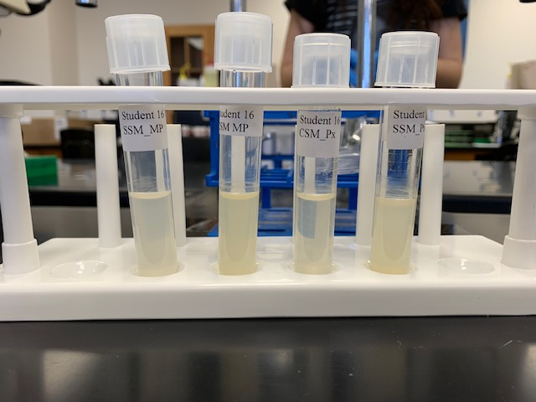 | 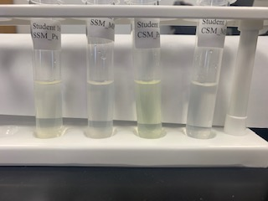 | 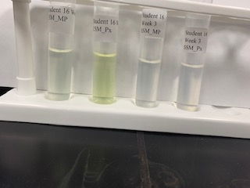 | 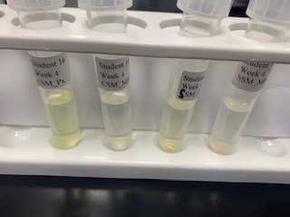 | 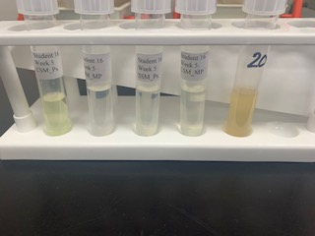

Week 5 Results
The image above is shown as the final week 5 results before plating the successful culture in the CSM_Px sample tube. The tube with the label of 20 is the revitalized culture from the CSM_Px tube.

T-Test Results
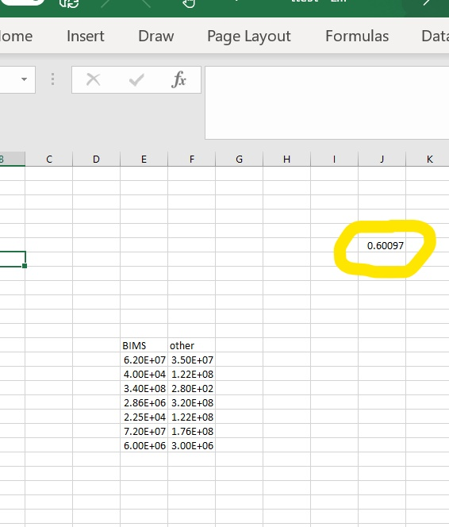
The image above depicts a T-test in which the P-value is shown to be greater than 0.05, indicating that the samples are not significantly different. The two variables being compared were samples from Biomedical Science majors (BIMS) vs. Other majors.

Conclusion and Discussion
In the final results shown in the Week 5 Results image, the CSM_Px sample was the only one to sustain the pesticide bioremediation bacteria. The revitalized culture is identified with the number 20 and was plated from the CSM_Px culture. This means that the bioremediation bacteria were able to metabolize the pesticide Paraxon, while in the Carbon selective medium. There is a clear color difference between the CSM_Px sample, and the other three samples in that the other three do not show significant color variation, indicating no pesticide metabolizing bacterial growth. Throughout weeks 2-5, the CSM_Px test tube maintains a stronger difference compared to the other tubes, indicating early on that this tube could contain the desired bacteria.
The T-test Results image depicts a T-test, or a statistical analysis that measures the significance between two variables and determines if the significance is due to random chance. The variables are considered significant if the P-value, or the number circled in yellow on the image above, is greater than 0.05. With the T-test calculating a resulting P-value of 0.60, there was no significant difference between samples of the BIMS majors compared to Other majors.

